roid

217, Sheikh Rashid Building

P.O Box 56272, Dubai

United Arab Emirates

Tel: +971 4 2973236

Email: uae@verbat.com

PROJECT   
PROPOSAL

**Integration of Jaheziya Training Management System (JTMS) with Civil Defense**

|  |  |
| --- | --- |
| **Prepared for:**  **Jaheziya** | **Submission Date:**  07 July 2018  **Proposal ID:** AD/BP/01072018/1929/1 |

___________________________________________________________________________________________________________________________________________  
Conﬁdentiality Notice: This Proposal is conﬁdential and contains proprietary information and intellectual property of Verbanet Technologies LLC. Neither this proposal nor any of the information contained herein may be reproduced or disclosed under any circumstances without the express written permission of Verbanet.

© 2018 by Verbanet Technologies LLC. All rights reserved. Confidential.

___________________________________________________________________________________________________________________________________________

Project Contacts

|  |  |
| --- | --- |
| Client Information | |
| Project Name | Integration of Jaheziya Training Management System (JTMS) with Civil Defense |
| Client Name | Jaheziya |
| Client Address | Abu Dhabi, UAE |
| Contact Person |  |
| Contact Person Email |  |
| Contact Person Phone Number |  |
| Verbat Information | |
| Contact Person | Joyce Daniel |
| Contact Person Phone Number | +971 4 2973236 Ext:102 |
| Contact Person E-Mail | [joyce.daniel@verbat.com](mailto:joyce.daniel@verbat.com) |
| Address | PO Box 56272, Dubai, United Arab Emirates |
| Physical Address | 217, Sheikh Rasheed Building, Hor Al Anz East |
| Project Information | |
| Proposed Technology/Methodology | PHP, MYSQL |
| Anticipate Start Date | NA |
| Proposal Valid For | 30 Calendar days from the submission of the proposal |

**Table of Content**

1 Executive Summary 4

1.1 Proposed Solution Model 5

1.2 Solution Objective 5

1.3 Advantages of Proposed Solution 6

6

1.4 Why Verbat 6

1.5 Key Differentiators 7

2 Functional Specifications 8

3 Nonfunctional Requirement (Others) 8

4 High Level Architecture 8

5 Assumptions 9

6 Out of Scope 9

6.1 Proposed System Environment 10

6.2 Technical Configurations 11

6.2.1 Development Tools 11

6.2.2 Recommended Web Hosting Package 11

6.2.3 Browser Compatibility 11

6.2.4 Hardware Interface 11

7 Commercials 12

7.1 Payment Terms 12

7.2 Mode of Payment 13

8 Delivery Management 14

8.1 Project Management 14

8.2 Roles and Responsibilities 14

8.3 Delivery Activity Summary 14

8.4 Project Implementation Plan 15

8.5 Deliverables 15

8.6 Estimated Delivery Time 16

8.7 Details (at Clients Behest) 16

8.8 Release Planning 16

8.9 Risk and Contingency Planning 17

9 Change Management 18

10 Miscellaneous 19

10.1 Acceptance Criteria 19

10.2 Warranty 19

10.3 General Terms and Conditions 19

10.4 Assumptions and Dependencies 21

10.5 Source Code & Intellectual Property Rights 21

10.6 Maintenance & Support 22

10.7 Service Level Agreement 23

11 Our Clients 24

# Executive Summary

Jaheziya, the brand name for Tawazun Safety, Security and Disaster Management City stands for “readiness” or “preparedness”. Jaheziya provide technical, vocational and professional training for intra-agency, interagency and multi-agency operations in the fields of safety, security, emergency preparedness, and crisis/disaster management. Initiated by Tawazun, Jaheziya aims to offer training that will help build, sustain and enhance the UAE’s capacity to protect communities, assets and vital infrastructure.

Verbat is a Digital Technology Services company with over 18+ years of experience in delivering Internet and Mobile Solutions to Enterprises, through Agile Development and Application Management methodologies. Application Development is an area where Verbat has in-depth knowledge and expertise. Being the pioneers in Web based solution across the major verticals, we are sure to help customers drive differentiation. We bring proven methodologies and processes, global expertise in application development, and a legacy of best practices & ready-to-fit frameworks to expedite the development cycle in order to reduce the total cost of ownership.

**Jaheziya** (here after referred to as “Client”), has requested **Verbanet Technologies** **LLC.**, trading as Verbat Technologies (hereafter referred as” Verbat”) to integrate the Jaheziya Training Management System with Ministry of Civil Defense.

Verbat is pleased to submit the proposal and values it as a great opportunity to have a long term & mutually beneficial association with the Client. Verbat has gone through the requirement and presents a proposal for the requested system.

## Proposed Solution Model

**Stand-Alone Fixed Bid**

Verbat will be following a stand–alone fixed bid solution delivery model wherein the required solution would be devised and a suitable pricing would be offered.

## Solution Objective

Following changes can occur on the integration between JTMS and Ministry of civil defense

1. Company Registration and User Authentication will happen in Ministry of Civil Defense website
2. User will view the Jaheziya training calendar loaded with trainings pertaining to civil defense in the Ministry of Civil Defense website.
3. Companies will view their employees and book them for different training sessions
4. Option of rescheduling/ cancelling the training by Civil Defense Companies will be restricted to 24 hours prior to the date of the training (training time)
5. Once the training is completed Jaheziya should push back the training attendance report to Ministry of Civil Defense
6. Survey Data will be shared to Civil defense and Civil Defense needs to create the survey Form. Once company submits the survey, the survey data is pushed to Jaheziya.
7. For the identification of trainees, Civil Defense can enter the Emirates ID number of trainees

Verbat’s Solution architects have conducted a thorough research on the requirements and have come to the conclusion that our proposed solution, which is detailed further in this document, will meet the requirements put forth by the client. And the proposed solution will be delivered in a phased approach as per Verbat’s stand-alone fixed bid solution model.

**Strong and Scalable platform:** The platform proposed will be strong and scalable enough to accommodate future enhancements.

**Accelerated solution:** The framework would act as a solution accelerator. It would provide the basic building blocks which could be reused in future for building new components and features.

**High performance:** The light weight framework used consumes fewer system resources thereby making the application perform faster.

**Security:** The application will be developed considering various aspects of security.

## Advantages of Proposed Solution

## 



01

Agile development offering reliable, secure solution

02

Smooth transition and quicker completion of processes

03

User friendly interfaces enabling easy navigation between screens

## Why Verbat

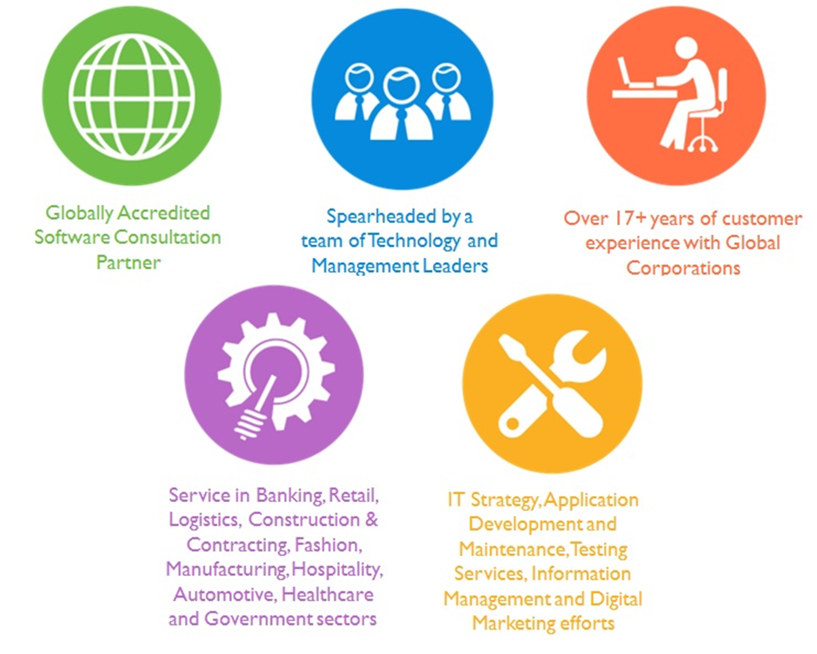

Over 18+ years of customer Experience with Global Corporations

## Key Differentiators

Delivered digital transformation expertise to global customers for over a decade by following industry best practices to maximize ROI for client

Keen technology intelligence combined with aggressive market research to deliver solutions that achieve results with measurable value

Enable access to global consulting expertise with strong local market and business knowledge

Commercial Model that is customizable for your business needs

Services that are designed to optimize applications for improved performance and overall efficiency

1,000,000 plus man-hours of expertise in technology frameworks spanning Microsoft, Open Source, mobility platforms and other proprietary IT technology

Partners top technology vendors to bring in the latest and best services in integration, collaboration, and development

Commercial Model that is customizable for your business needs

Proven Methodologies & Processes

Investment in R & D

Strong Local Presence

Flexible commercial Models

Technology Associations

Software Development Experience

Offshore Development Centre

Quality Assurance & Testing

# Functional Specifications

## Web Application

**Integration of Jaheziya Training Management System with Civil Defense**

|  |
| --- |
| **Scope of Work** |
| Companies registered in Civil Defense will login to their portal |
| Companies will view Jaheziya Training Calendar and Book the trainees |
| Enroll trainees and store fingerprint information in the database |
| Necessary Trainee details will be pushed to the JTMS |
| Trainee punch-in verification : Mark attendance by matching finger print images stored in the system with the image scanned by the fingerprint scanner |
| Option to be provided in the Jaheziya Training Management System to add/replace trainees for civil defense training programs |
| New user in JTMS called “Registration Executive” will have a module called “Add trainees to Training session”. EID Card Reader application to be implemented for verifying the trainee details.  ** User can be added to already existing Civil Defense Training session. This addition will take place through Emirates ID Integration. |
| Jaheziya will verify the authenticity of the trainees by logging into the Ministry of Civil defense (manually) |
| All the Trainees added or replaced by Jaheziya in both Civil Defense trainings or Jaheziya trainings will be through Emirates ID. |
| Once the training is completed Jaheziya should push back the final list of trainees who attended the training to Ministry of Civil Defense. Pushing attendance API will be provided by Ministry of Civil defense to push the attendance data once the session has been completed. |
| Survey Data will be shared to Civil defense and Civil Defense needs to create the survey Form. Once company submits the survey, the survey data is pushed to Jaheziya. Attached the screenshot of current survey in JTMS. Civil Defense to revert on the Survey Content. |
| Note: Except from pushing of attendance, all other API’s will be written by Verbat |
| Company Information: Following are the details that JTMS require from a company :  1. Name  2. Name in Arabic  3. Type of Business  4. Location  5. Designation  6. Email ID  7. Contact Person Name  8. Contact Number  9. Maximum number of trainees |
| Following are the details that JTMS require for booking a trainee :  1. Name  2. Nationality  3. Gender  4. Date of Birth  5. Emirates ID Number  6. Job Title  7. Mobile Number |

## Mobile App

1. Enroll trainees – this will be happened in Civil Defence end.
   1. Option to add trainee’s unique ID and Fingerprint scanning via biometric scanner.
   2. After submit application will store the biometric information against corresponding trainee.
2. Punch In – This will happened in Jaheziya end
   1. Option enter trainee unique ID and Fingerprint scanning via biometric scanner.
   2. After submit, application will verify the fingerprint and mark attendance if fingerprint match return success.

# Nonfunctional Requirement (Others)

|  |  |
| --- | --- |
| **Requirement** | **Details** |
| User Experience and  UI Design | * The web app for the client admin will be developed in English * The layout and graphical components will be created considering the usability factors |
| Performance | * Application will allow users to have smooth and quick access to the information or services they require. |
| Security | * Web security standards will be followed. |

# High Level Architecture

# Assumptions

The project solution and technology is created from the initial understanding of the requirement shared with Verbat through mails and meetings. The proposed solution is based on the following assumptions:

# Out of Scope

With the ever-evolving digital market, the requirement needs should be clear to both the parties involved, hence the importance of mentioning the out of scope details of the project. Following are considered to be out of scope while creating this proposal.

## Proposed System Environment

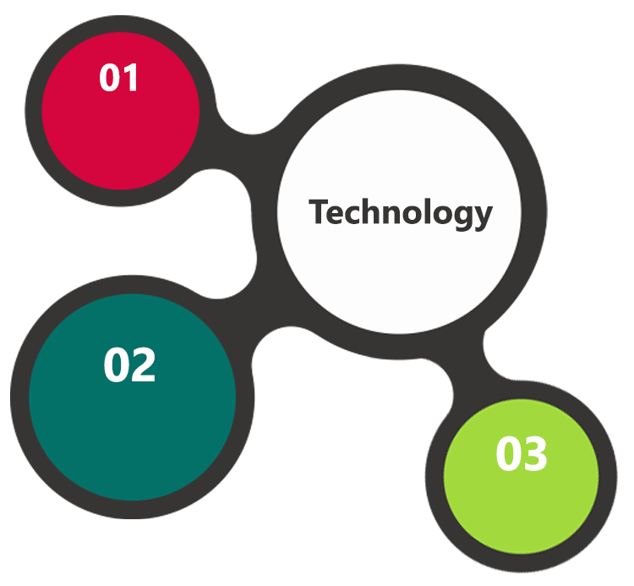

PHP, Code Ignitor

Objective C, Android SDK, IOS SDK

SDK

HTML / CSS3 /

JQuery

MySQL, APACHE

**MS SQL2012  
Windows 8/10  
Web Services**

## Technical Configurations

### Development Tools

* PHP, Code Igniter, Objective C, Java
* MSSQL, APACHE
* HTML / CSS 3
* Ajax, JavaScript, JQuery

### Recommended Web Hosting Package

* Octa Core CPU
* RAM: 32 GB
* Disk Space: 1 TB
* Monthly Bandwidth: 20 TB
* Web site Server Software – Apache

### Browser Compatibility

* Chrome version: 56
* Firefox version: 51
* Edge version: 39
* Safari version 10.1

### Hardware Interface

The application is reliant on hardware interfaces to provide a seamless automated user experience.

* Computer with Windows 8 or 10 OS
* iOS (9.0 and above) iPhone 5S and above

# Delivery Management

## Project Management

The Verbat development center strictly follows industry standards on quality. The project management is process governed by the Verbat Quality Management system and is put to verification through internal audit programs that happen from time to time.

Verbat will dedicate a project manager for the proposed implementation. Verbat proposes Client to identify one project manager who will be driving activities to be undertaken by Client to be the single point of contact for Verbat.

## Roles and Responsibilities

Verbat will assign a dedicated Project Manager/Project Lead to lead the project, who will be the first point contact for Client. He/she will be responsible for planning and managing the various activities within the project. He/she will work closely with Client Project Manager, to give periodic status updates and ensure high level of visibility and comfort on the progress of the project.

The Project Manager/Project Lead will lead the co-ordination between Verbat and Client, thus enabling smooth transitioning of Client requirements to the Verbat’s offshore delivery team, and provide visibility as well as comfort on the progress of the services to Client.

He/she will have periodic meetings with Verbat’s Senior Management, thus ensuring Verbat’s Management commitment and focus on Client initiatives.

## Delivery Activity Summary

|  |  |
| --- | --- |
| Activities | Description |
| Detailed requirement Analysis | Verbat team to conduct detailed study of requirement for the phase. If clarification is required, team will reach out to Client for more information and/or time for discussions. |
| DB Design | DB design for central and test DB. |
| Software Requirement Specification document (SRS) | Once the requirement analysis is completed, Verbat team will submit the SRS document for approval |
| UI/UX Design, Prototyping | Based on the SRS, Verbat UX/UI team will work on the UI/UX of the screens and submit a prototype for approval |
| Functional Specification Document (FS) | Once the Prototype. UI/UX is approved, Verbat shall submit an FS document for approval. |
| Development | Actual system development starts based on the FS. This involves detailed design and software development of Web Admin, API & iOS and Android mobile app. |
| Testing | Test Planning, test plan creations, internal, integration testing and user acceptance testing. |
| Deployment | Deploying the latest built in the Verbat Test Server. |

## Project Implementation Plan

Verbat will be providing the solution in a stand-alone fixed bid approach which ensures minimum viable solution for quick wins with core focus on the long-term business objective and outcome. Once the implementation is over, Verbat will initiate the application maintenance process (once the maintenance contract is signed) which continues to extend after the implementation.

## Deliverables

* Project Plan
* Software Requirement Specification Document (SRS)
* Prototype for Web and Mobile App
* Functional Specification Document (FS)
* Fully Developed & Tested Application
* Source Code

## Estimated Delivery Time

**14 Days ----------------------------**

| **Activity** |
| --- |
| Contract Signoff (T0) |
| Project Initiation & Initiating requirement gathering |
| Software Requirement Specification Document(SRS) |
| SRS Approval (T1) |
| System Prototype-Complete |
| System Prototype-Approval (T2) |
| Functional Specification (FS) |
| FS Approval (T3) |
| Development Phase-Complete |
| Perform QC (Unit Testing and Integration Testing) |
| System ready for UAT |
| UAT Acceptance on Verbat server (T4) |
| Release of the application with source code to Client (T5) |

## Details (at Clients Behest)

* Client can opt for hosting the application at Verbat’s Server.
* If deployment is at the Client’s server, responsibility of deploying the application onto the production environment after conducting the necessary acceptance testing will lie with the Client unless and until Verbat’s support is contracted for deployment.

*Note: Hosting the application at Verbat’s server will call in for additional charges.*

## Release Planning

* Client will be informed about the release date and time through email.
* Client performs the UAT

## Risk and Contingency Planning

Verbat has identified various risk factors associated with this assignment and understands the impact of these risk factors on the project schedules. The objective of this section is to highlight for both Verbat and client, the risk factors, to analyze the impact of the risks on project execution, and to propose strategies to control and reduce the impact of the risk factor.

These various risks, which could arise during the project, are tabulated below along with mitigation implementation.

| Type of risk | Impact | Risk Mitigation | Risk Handling |
| --- | --- | --- | --- |
| Scope Creep | H | Functions and features will be detailed in system requirement documents and will go through client approval. Once this document is approved, any change to requirement will go through change management review for possible impact assessment. | Proper change management procedure will be implemented. |
| Delay in customer feedback | H | The plan is prepared with enough lead-time for customer reviews and approvals.  The customer is indicated with the dates when the document is expected after review and approval. | The request for feedback will be escalated if not attended at the right time so that the schedules are not affected. Deemed acceptance criterion is set up front and will be followed. |
| Non-availability of necessary software’s, frameworks, database instances and infrastructure at client’s hosting environment(If hosting support is provided by Verbat) | M | Client will be informed in advance on these requirements. | Possible impact to schedule. |
| Manpower attrition | L | All efforts would be made to ensure process dependence rather than being person dependent. As a risk mitigation plan Verbat will train backups. | A new person will be identified as early as possible, provided the required project-specific training and mentored by the senior members of the team to minimise impact of attrition on the project. |

*H-High, M-Medium, L-Low, NA-Not Applicable*

# Change Management

Any addition which comes out of the project scope, upon and after the launch of the tool will be considered as change management. Verbat recommends the following change management procedure for the same.

* Any change which comes out of the project scope, which was discussed, documented, and mutually approved by both the parties in the requirement stage, will be carried out only through raising a change request.
* Change request will be studied and an impact analysis on the existing work flow will be performed.
* On finalizing the impact, effort estimation for the change will be calculated and raised as additional requirement.
* Verbat will initiate the change request only after getting a formal approval from the client for the additional changes raised.
* Any change from the scope will be charged at **USD 320.00 per man day effort** and approval from the clients will be availed before commencing on any change management.

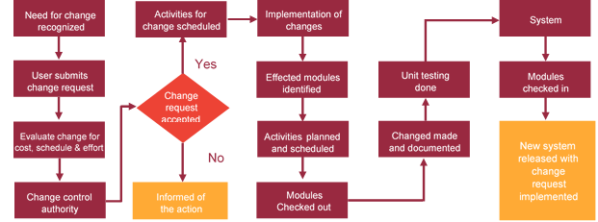

# Miscellaneous

## Acceptance Criteria

* UAT sign off should happen within 14 Days from the release of each module/ Phase and the acceptance confirmation needs to be mailed to Verbat failing which Verbat will consider the project as approved by the Client.
* Any comments or reason for rejection need to be documented and the same needs to be sent as an email from the official mail id of Client to Verbat on or before 14 days from the first release.
* Timeframe for acceptance for any further release will be mutually agreed and finalized between Client and Verbat depending on the UAT Comments.

## Warranty

* Verbat shall provide a bug ﬁx warranty at no additional cost for 30 days from the date of acceptance of the project, for correction of any errors in the developed application that may be attributed to Verbat.
* However, this does not cover modifications by Client, or use of the application on an environment other than the proposed environment, or other circumstances outside Verbat’s reasonable control. In such a case Verbat reserves the right to charge for its services.
* All error corrections will be executed at Verbat India office. In the event of any need for on-site work, all expenses incurred for such trips will be payable to Verbat by Client.

## General Terms and Conditions

* Offer Valid for 30 calendar days from the date of submission of the Proposal
* An average of 20 working days are assumed in a month
* All the projects activities will be carried out from our off-shore development center in India
* All the documentation will be provided in English.
* Third party components may be used to develop this application.
* The scope of the project is to develop the Application as detailed in the scope of the project and mentioned in this proposal. Any changes or additions will have to go through change management.
* This proposal would have been derived or concluded from either the RFQ /RFP/data shared via email / information transferred during an initial requirement analysis meeting / tele-conversation. Verbat Technologies reserves the right to change the terms of this proposal as the final terms (including the costing), features & functionalities and timeline could change during the course of the project. Hence any fees quoted / timeline committed in this proposal may not be considered as final unless agreed and signed by both parties.
* Web Application will be best viewed only in the environment mentioned in the section Browser Compatibility
* Mobile app will be best viewed only in the environment mentioned in the section Hardware Interface
* All Source Code and other project artefacts would adhere to the Verbat document templates and internal coding standards
* Acceptance criteria shall be based on the clauses which were mutually discussed between Verbat and Client at the Requirement Analysis phase and the same will be documented and approved by both parties through official emails
* In case Client requires any extension of the proposed acceptance schedule, the associated effort and cost of such extension can be mutually reviewed
* For any circumstances if project needs to be put on Hold / Stop it requires minimum request notice period of 14 days along with duration for which request will be addressed by management and final decision on the request will be based on that
* If deployment is done in Client’s server, Verbat cannot be held responsible for any performance issues arising due to hardware malfunctions.
* Client is responsible for data backup in case the application is not hosted on Verbat server
* Source code will only be delivered or uploaded on the Production Server once the due payments are made.

## Assumptions and Dependencies

* Detailed system study is required before the start of the project.
* During the requirement gathering phase, authorized personnel from the Client’s side is expected to be available for discussion and finalizing the HLD (High Level Design), before development commences.
* Type of reports and formats, if under the scope of the project, needs to be specified by Client before project sign off.
* Workflows if under the scope of the project, need to be specified/ confirmed by client before project signoff.
* Verbat assumes that all sign-offs from Client will be provided within agreed and specified timeframe.
* Client will provide all the necessary contents, both text and image, before starting the project in the format suggested by Verbat (if any).
* The client should provide the relevant information and data well in time for the execution of a related activity. Non- availability of this information or data may lead to an interruption of work which may result in a delay in delivery as well as additional costs to the client.
* Client should have/possess server with technical specifications as suggested by Verbat for the proposed application.
* Client will be provided with one time training (train the trainer) on how to use the application via video conference (maximum of 4 hours). Additional training requests will be charged.

## Source Code & Intellectual Property Rights

* Upon completion of the Project and 100% completion of the payment, client will have access to the source code except for propriety codes, developer tools and third party application etc.
* The solution offered will be the intellectual property of the client and will be made available to the client on an “unlimited license” basis.
* Modifications by third party/person: No person or organization, other than Verbat or any person authorized by Verbat in writing, has any permission to modify/change the software Solution to be eligible to get continued support from Verbat as per the support terms defined under this document.
* Liabilities/Damages: Verbat accepts no liability or damages of any kind arising out of use or non-use of the software delivered. The responsibility of testing of software lies with Client.

## Maintenance & Support

* Maintenance contracts by default are supported as per the basic SLA terms.
* **AMC with Basic SLA is charged at 30 % of the total project value**. Additional Effort/change management request will be added towards Total Value of the Project to determine the AMC value.
* Maintenance support is limited to providing application support for ensuring the consistency of the look-and-feel, bug fixes and user issues i.e. maintenance and support of the existing features of the application.
* Support does not in any way cover providing technical or other support to the end users. The maintenance agreement does not include functionality changes or feature additions which are handled as change requests which will be charged USD 320.00 per man day. AMC does not include server support, maintenance and application deployment.
* AMC charges will cover Off-Site Support and Debugging. Support includes E-mail, Telephone unless explicitly specified. In the event, the application is hosted with the client; necessary remote desktop connectivity should be provided for carrying out maintenance activity.
* Gap in AMC - In case if the client does not opt an AMC for a year and want to renew it after that period, 50% of the AMC amount for the year for which AMC is not taken will also be payable if the client wishes to renew the AMC contract.
* Note:
  + Please note that the AMC support shall start only after all the necessary sign-offs (AMC Document) to this effect have been given.
  + It is not mandatory that the client should opt for an AMC. The client will still be supported on an ad-hoc basis on an agreed man-day rate.
  + AMC Payment Terms: 100% to be paid as advance.

## Service Level Agreement

|  |  |  |  |  |
| --- | --- | --- | --- | --- |
| **Key** | **Max Response Time** | | **Max Resolution Time** | **Target** |
| Basic | 1  working day | 3 working days | | Request / incident / problem tickets |
| Advanced | 5 Business Hours | 12 Business Hours | | Request / incident / problem tickets |
| Priority | 3 Business Hours | 5 Business Hours | | Request / incident / problem tickets |

Note:-

* We provide Basic SLA as standard with AMC while Advanced and Priority SLAs attract additional charges.
* Time zone applicable as per India time zones (3:30 AM GMT to 12:30 PM GMT- Monday to Friday).

AMC Option:

* Client can opt for time and material based Annual Maintenance, the details of which will be shared post the completion of project.

# Our Clients

**UAE University**

Education

Transportation

**Canada Cartage**

Construction

Services

Finance

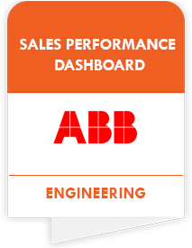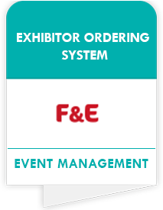

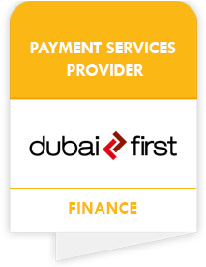

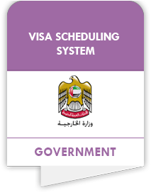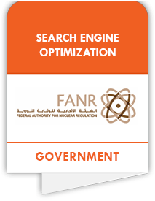

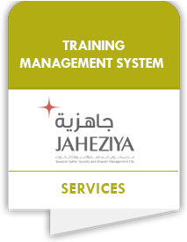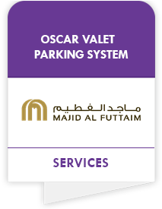

We look forward to hearing from you soon and hope that you will give us the privilege to work with you in meeting your business goals. Thank you.

Thank You



©   
1999 - 2018. All Rights Reserved   
Verbanet Technologies LLC  
www.verbat.com